**Knightmare**



**Kennard Kee Wei Sheng (130214X)**

**Lee Zheng Yi, Shawn (132784P)**

**Shum Weng Sang (132067D)**

TABLE OF CONTENTS

1.0. Game Overview 3

1.1. Introduction 3

1.2. Genre and Target Platform 3

1.3. Target Market 3

1.4. Unique Selling Points 3

2.0. Game Mechanics 3

2.1. Game Play 3

2.2. Game Elements 3

2.3. Game Flow 3

2.4. Input System/Key Features 4

2.5. Scoring System 4

3.0. Level Designs 4

3.1. Level 1 4

3.2. Level 2 4

3.3. Level 3 4

3.4. Level N 4

4.0. User Interface 5

4.1. Heads Up Display 5

4.2. Game Menus 5

# Game Overview

## Introduction

Knightmare is a puzzle game where the player takes on an endless wave of chess pieces as the knight piece. Pawns will randomly spawn at any side of the board and gradually move one space at a time till they reach the end and promote to another piece. Players have to navigate in the knights L shape and can chain the capture of enemy pieces for high combo scores.

## Genre and Target Platform

Action puzzle. Target platform: Android tablets.

## Target Market

Casual puzzle players and chess fans

## Unique Selling Points

Chess themed gameplay.

Information is clearly conveyed in the highlighted squares.

# Game Mechanics

## Game Play

Players choose among the eight possible moves a knight can make. If it would capture an enemy piece, players are given another chance to move and so on. Players are trying to clear as much of the board as possible before being overwhelmed by pieces and racking up combos and score. The game is played in turns, after the player has moved, the pawn pieces remaining move one space and more spawn. If the knight lands on a threatened square mid move or at the end of their move, he takes one damage. The player loses when all their 3 lives are gone.

## Game Elements

Player: A black knight chess piece



Pawn: The most basic of enemies, players can see which direction the pawn will move by seeing which squares they threaten and which way they are oriented. Players can turn on the option to see all the threatened squares or just tap on an enemy to know which squares they threaten.



Bishop, Rook, Queen, King and Knight

Pawns when they reach the end of the board will promote into a bigger piece that can threaten a greater number of squares but are worth more points.

Power-ups

Health up: Gives the player one more health

Wall: Creates a wall on a square that blocks enemy movement and allows the player to use them to combo jumps.

Teleporter: Allows the player to move to another unoccupied square on the board. Positioning is particularly important due to the L shape movement of a knight piece.

## Game Flow

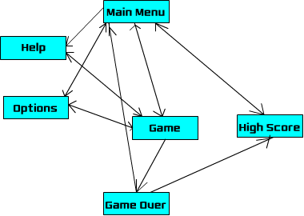

## Input System/Key Features

Players need only tap on where they wish to go and what elements they wish to highlight.

To move, the player selects the knight and it will be highlighted as well as the eight spaces it can move to. Players then tap on the square they wish for the knight to land on.

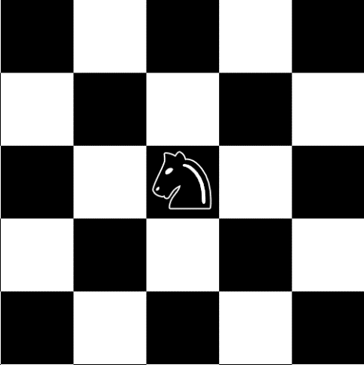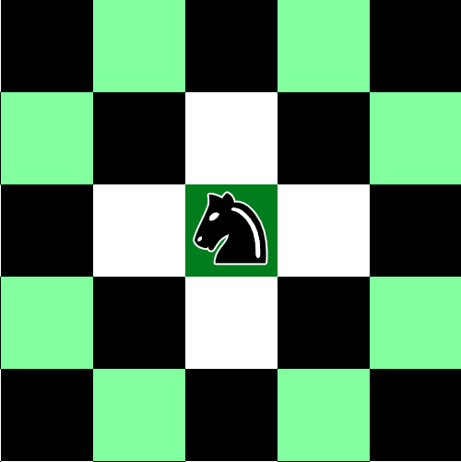

## Scoring System

(Value of the piece captured) * combo multiplier

For example 2 pawns (10 points each) are captured, followed by 1 bishop (30 points).

(10 * 1) + (10 * 2) + (30 * 3) = 120

# Level Designs

There is only one level but the difficulty will gradually increase. The game will start with only a few pawns but eventually there will be too many to capture before some of them promote. Eventually, the player will have no choice but to take damage to capture a troublesome piece.

# User Interface

## Heads Up Display

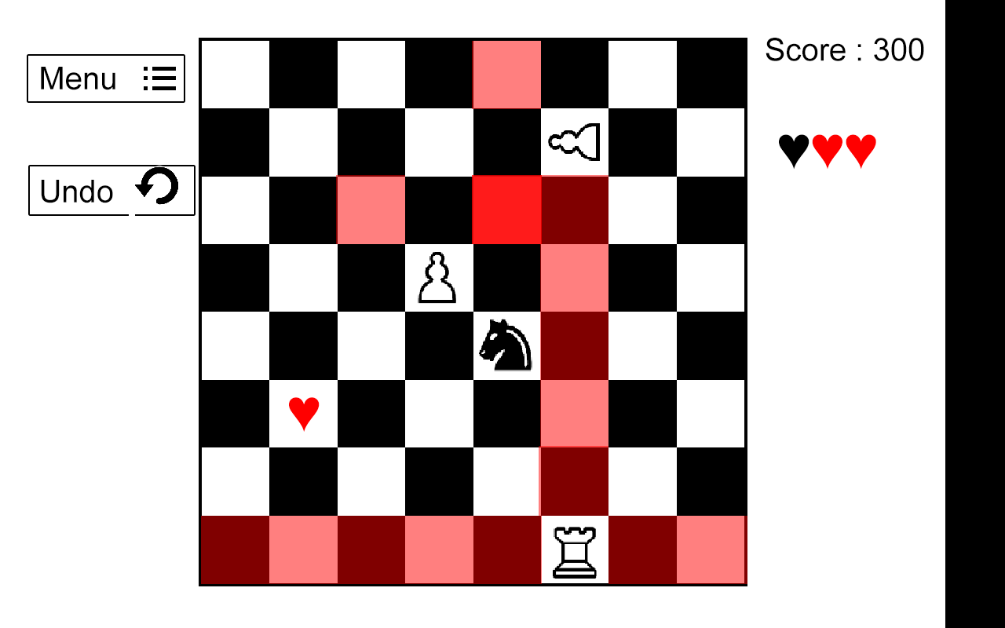

The squares in red are the squares being threatened. The player can toggle if they wish to see all the red squares. If they tap on an individual enemy, the squares they threaten will only be highlighted.

## Game Menus

**Main Menu**

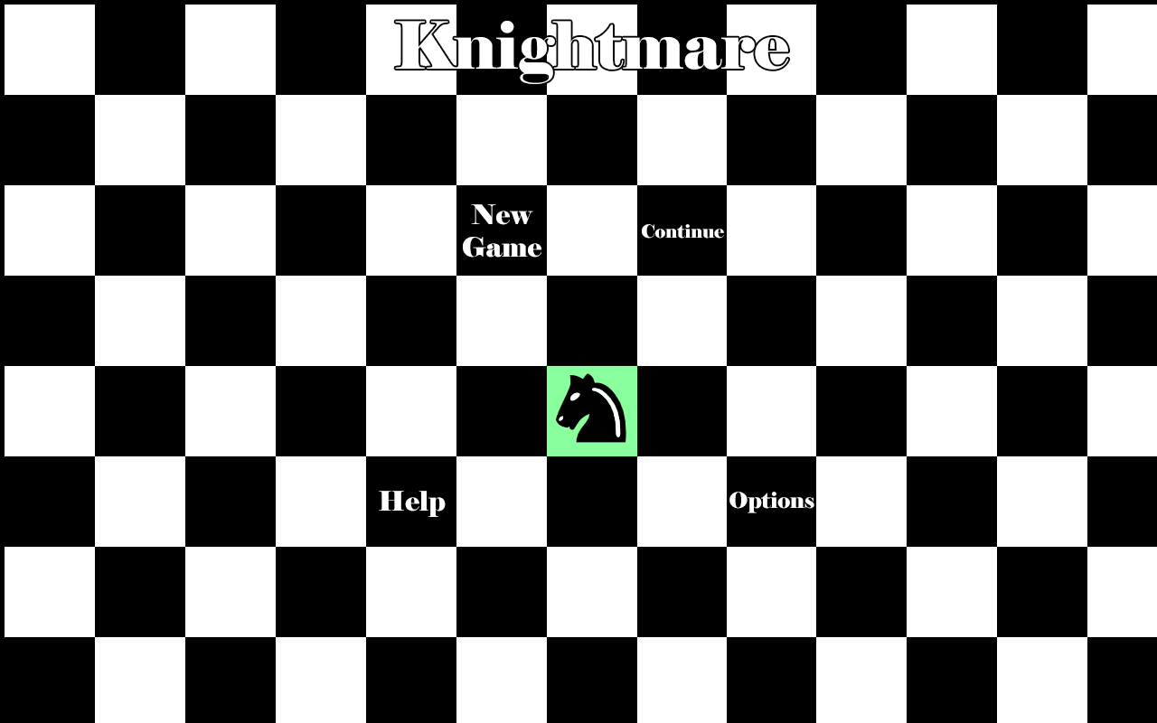

A very simplistic menu to draw the player’s attention to the knight and use it to select the menu options. It also gives a quick tutorial on the gameplay. The player cannot start by just tapping the start square, he must tap on the knight which will show the squares which the knight can land on. They can choose other squares and may end up lost so we will add a restart button on the start square after the knight has left the center.

**Options Menu**

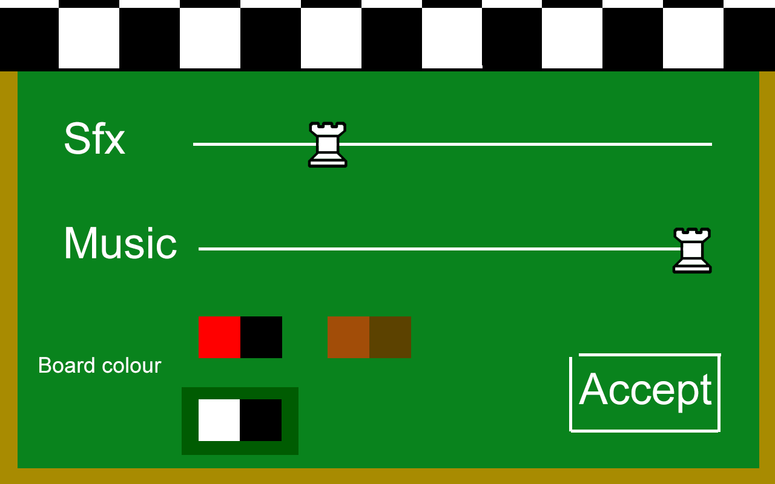

When the player selects the option menu, the board will move upwards and the drawer used to keep the chess pieces will open to reveal the options menu.